Wireframe Document

Heart Disease Diagnostic Analysis



Revision Number : 1.1

Last Date of Revision: 21/03/2023

*Mayank Deopa*

**DOCUMENT VERSION CONTROL**

|  |  |  |  |
| --- | --- | --- | --- |
| **Date Issued** | **Version** | **Description** | **Author** |
| 24 / 02/ 2023 | 1.0 | Introduction Wireframe design | Mayank Deopa |
| 21/ 03/ 2023 | 1.1 | Final Revision | Mayank Deopa |
|  |  |  |  |

# We Performed Exploratory Data Analysis on Jupyter Notebook and then created a Dashboard on Google Data Studio.

1. 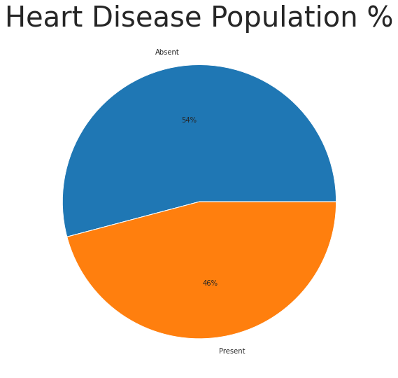**What kind of Population do we have based on Heart Disease?**
   * 46% of people are suffering from heart disease.
   * 54% are not suffering from heart disease.

# Which age category more prone to Heart disease?

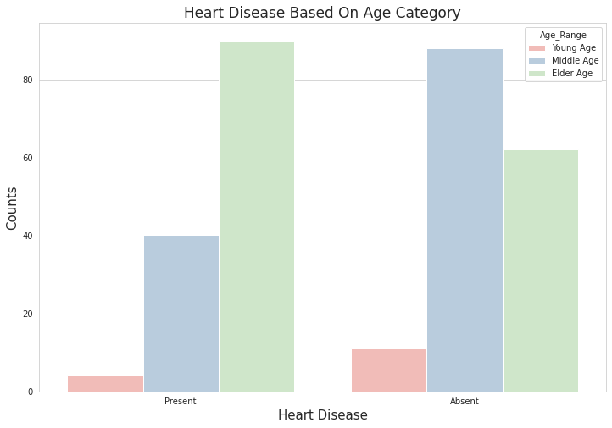

* Elderly Age population is suffering from heart_disease while,
* Most of the Young and Middle Age population are free from heart_disease.

# What kind of Chest pain is more common in Heart disease patients?

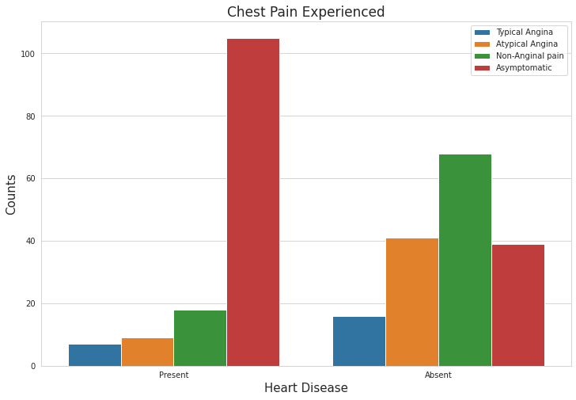

* + It seems that people with asymptomatic chest pain are more prone to heart disease.
  + Asymptomatic Chest pain means neither causing nor exhibiting symptoms of heart disease.
  + It seems high number of cholesterol level in people having heart disease.

# Which age group experience more Blood Pressure and prone to heart disease?

* We can see that BP increases from age 50 to 60 and the pattern will somehow tend to continue till 70.

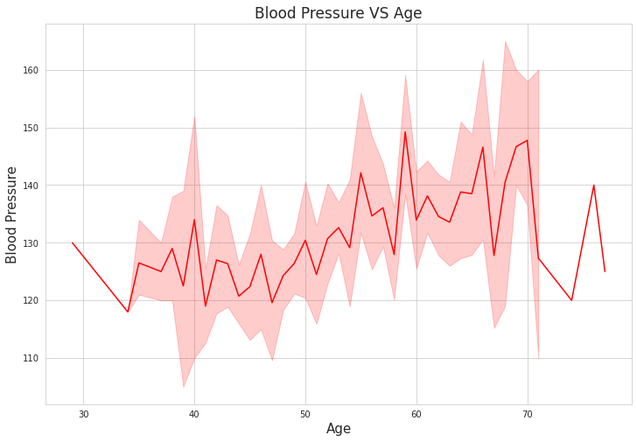

# 4. DASHBOARD ON HEART DISEASE ANALYSIS USING BI TOOL - GOOGLE DATA STUDIO.

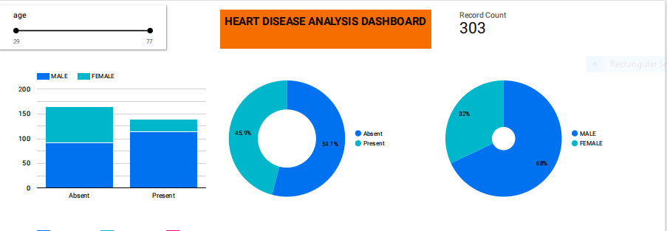

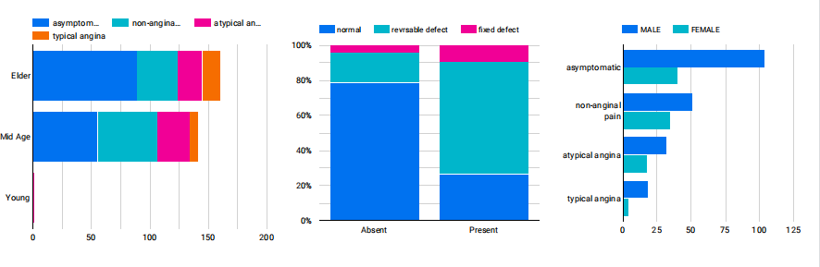

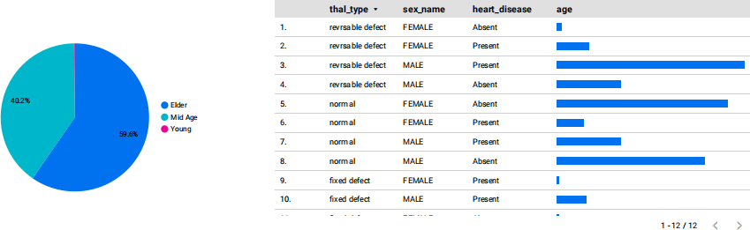

**Link to the Dashboard report :** [**https://datastudio.google.com/reporting/698802ee-182f-4c1d-9151-a7**](https://datastudio.google.com/reporting/698802ee-182f-4c1d-9151-a77aa1cc0c9b)[**7aa1cc0c9b**](https://datastudio.google.com/reporting/698802ee-182f-4c1d-9151-a77aa1cc0c9b)